SOCIAL MOOD MATCHER

Team ID : SWTID-2026-6915
Team Size : 5
Team Leader : KEERTHANA M C
Team member : KARTHIKA S
Team member : EMAN A
Team member : FARJANA S
Team member : ANISHA JERLIN R

AI-Powered Social Media Caption & Hashtag Generator

Project Description
Creating engaging social media content with suitable captions and trending hashtags can be time-consuming for content creators, marketers, and social media managers. They often spend a considerable amount of time crafting the perfect caption, searching for relevant hashtags, and ensuring that the content fits within the character limits of different social media platforms. This process can slow down content creation and reduce overall productivity.
Social Mood Matcher addresses this challenge through a GenAI-powered social media content generation platform that creates personalized, sentiment-aware captions along with trending hashtags optimized for various platforms. The system uses advanced image analysis techniques to understand both the mood and visual context of uploaded images. It employs BLIP for image captioning and DistilBERT for sentiment analysis to interpret the emotional tone of the content. Additionally, Google Gemini 2.5 Flash can be optionally integrated to enhance the quality and relevance of the generated captions and hashtags.
The platform assists content creators in generating engaging captions in various styles, such as casual, aesthetic, professional, and playful. It also offers curated trending hashtags organized by category and sentiment to enhance content visibility and audience engagement. Furthermore, the system ensures that all generated content complies with platform-specific character limits, including Twitter/X (280 characters), Instagram (2,200 characters), and Facebook (63,206 characters). By integrating intelligent sentiment detection, adaptive caption generation, and multi-platform compatibility, Social Mood Matcher simplifies and enhances the social media content creation process, making it more efficient and user-friendly.

Use Case Scenarios

  - Scenario 1: Food Photography with Mood Detection
A food blogger uploads a cozy photo of a homemade soup. The AI analyzes the image using BLIP to understand the visual context (e.g., “a bowl of soup on a wooden table”) and uses DistilBERT to identify the sentiment, such as “cozy” or “warm.” Based on this analysis, the system generates a caption in the user’s selected style—for example, “Nothing beats a warm bowl of homemade soup on a chilly evening.” It also suggests relevant hashtags like #FoodPhotography, #CozyVibes, #Homemade, and #ComfortFood. The generated content is automatically formatted for the chosen platform (such as Twitter) and ensures it stays within the 280-character limit.

  - Scenario 2: Travel Content with Multi-Style Options
A travel influencer uploads a photo of a sunset at the beach. The platform analyzes the image and detects the mood as “peaceful” and “aesthetic.” Using the Gemini-enhanced mode, the system generates multiple caption options in different styles, such as aesthetic (“Golden hour whispers stories only the ocean knows”), punchy (“Sunset state of mind”), and casual (“Beach sunsets hit different”). The user can preview all the caption variants, choose their preferred one, and receive platform-optimized hashtags like #TravelPhotography, #SunsetVibes, #BeachLife, and #GoldenHour. The system also ensures that the hashtags and caption are properly formatted to fit Instagram’s posting style.

  - Scenario 3: Brand Content with Character Limiting
A marketing professional uploads a product photo for a luxury brand. The AI analyzes the image and detects sentiments such as “luxury” and “elegance.” Based on this analysis, the system generates a professional-style caption without emojis and suggests premium hashtags like #LuxuryLifestyle, #Premium, and #Elegance. The platform also applies smart character limits for Twitter. If the combined caption and hashtags exceed the 280-character limit, the system intelligently shortens the hashtags while preserving the complete caption, ensuring that the main message remains clear and impactful.

Architecture Overview
Social Mood Matcher is an intelligent and modular platform designed to generate personalized, sentiment-aware social media content. The system integrates a Streamlit-based frontend with multiple AI models to process and analyze images. It utilizes BLIP for image captioning and DistilBERT for sentiment analysis to understand the visual context and emotional tone. Additionally, Google’s Gemini 2.5 Flash can be optionally used to produce higher-quality captions and improved content suggestions.

Core Technologies
•Streamlit: Frontend framework for interactive UI and real-time content generation
• BLIP (Salesforce): Image captioning model for understanding visual content
• DistilBERT: Sentiment analysis model for mood detection
• Gemini 2.5 Flash (Optional): Enhanced AI for superior caption quality and visual intelligence
• Python-DOCX: Export captions to Word documents
• ReportLab: PDF generation with professional formatting
• Pillow (PIL): Image processing and manipulation
• Transformers (Hugging Face): AI model integration and inference

Got you Let’s clean this up and turn it into a proper, presentation-ready table.
Here’s your Component-Wise Architecture in structured table format:

Component | Description
Frontend Interface | A Streamlit-based user interface that enables users to upload images, select caption styles, choose the desired social media platform, and view generated results instantly. It also provides options for viewing sentiment indicators, multiple caption suggestions, and exporting the generated content.
Image Sentiment Analyzer | This module analyzes the uploaded image to understand the scene and emotional tone. It uses BLIP for image captioning and DistilBERT for sentiment analysis to detect moods such as happy, calm, aesthetic, adventurous, romantic, and nostalgic

Caption Generation Module | Generates meaningful and engaging captions based on the detected sentiment, selected style (casual, aesthetic, professional, or playful), and the category of the image such as food, travel, nature, or lifestyle
Hashtag Recommendation Engine | Suggests relevant and trending hashtags according to the image content and detected sentiment. It organizes hashtags based on popularity and relevance to improve social media engagement.
Character Limit Controller | Ensures that generated captions and hashtags follow the character limits of different platforms. For example, Twitter allows up to 280 characters, Instagram allows up to 2,200 characters, and Facebook supports longer captions.
AI Enhancement Layer (Optional) | Integrates Gemini 2.5 Flash to enhance caption quality, generate multiple caption variations, and improve contextual understanding of images for more creative and accurate social media content.

Pre-requisites
- 3.10+: Download from https://python.org Python
- Streamlit Framework: See https://docs.streamlit.io
- Google AI Studio Account (Optional): For Gemini API access at https://makersuite.google.com
4.First, install Python 3.10 or later fromhttps://python.org.
5.The project uses the Streamlit framework for building the web interface, which can be learned from https://docs.streamlit.io
6. Required Python Libraries: Listed in requirements.txt
7. System Requirements: 4GB+ RAM for AI model inference
8. Internet Connection: For model downloads and optional Gemini API

Project Workflow
The Social Mood Matcher project follows a structured five-milestone development process, spanning from the initial setup to full production deployment. Each milestone builds upon the previous one, progressively shaping the system into a complete, production-ready application.

  - 1. Environment Setup & Configuration
• Set up project structure and file organization
• Configure environment variables and API keys
• Install dependencies and verify installations
• Test AI model connectivity (local and Gemini

  - 2. Core Services Development
• Implement Image Sentiment Detector service
• Build Caption Generator with multiple styles
• Create Hashtag Engine with 2024 trends
• Develop Character Limiter for platform optimization
• Integrate optional Gemini service layer

3. Backend Implementation

• Design modular Flask-style architecture in Streamlit
• Create utility functions for image and text processing
• Implement session state management
• Build error handling and logging systems

4. UI Development
• Design responsive Streamlit interface
• Create image upload and preview functionality
• Build sidebar controls for style and platform selection
• Implement tabbed results display
• Add export and download features

  - 5. Testing & Optimization
• Perform comprehensive testing across all feature
Optimize AI model performance and caching
• Validate character limiting accuracy
• Test multi-platform compatibility
• Prepare deployment configuration
  - MILESTONE 1: Environment Setup & Configuration
The goal of this initial stage is to establish the development environment and properly configure all required tools, libraries, and AI services for Social Mood Matcher.

  - Activity 1.1: Project Structure Setup
Create the project directory structure with proper organization for services,
utilities,configuration, and tests

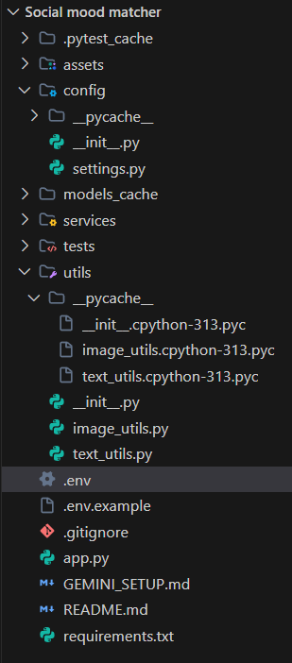
Activity 1.2: Install Dependencies
Install all required Python packages using pip. The requirements.txt file lists the libraries needed to run the Social Mood Matcher project, including Streamlit for the web interface, Transformers and PyTorch for AI model processing, Pillow for image handling, and optional Gemini API support for enhanced caption generation. Installing these packages ensures that all dependencies for the application are properly set up in your development environment.
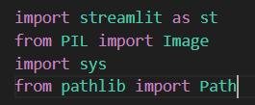
Activity 1.3: Configure Environment Variables
In this step, a .env file is created to store essential configuration settings for the Social Mood Matcher project. This file can include the optional Gemini API key, the model cache directory for storing downloaded AI models, and debug settings for development and troubleshooting. Using environment variables helps keep sensitive information secure and makes it easy to configure the application without modifying the main code.

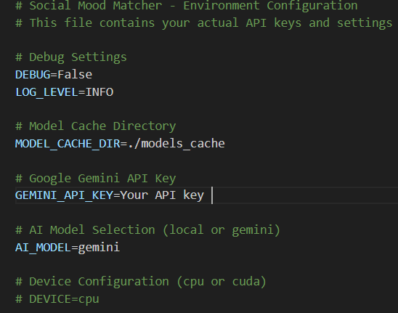
Activity 1.4: Optional Gemini Setup
- Visit GoogleAIStudio: https://makersuite.google.com/app/apikey
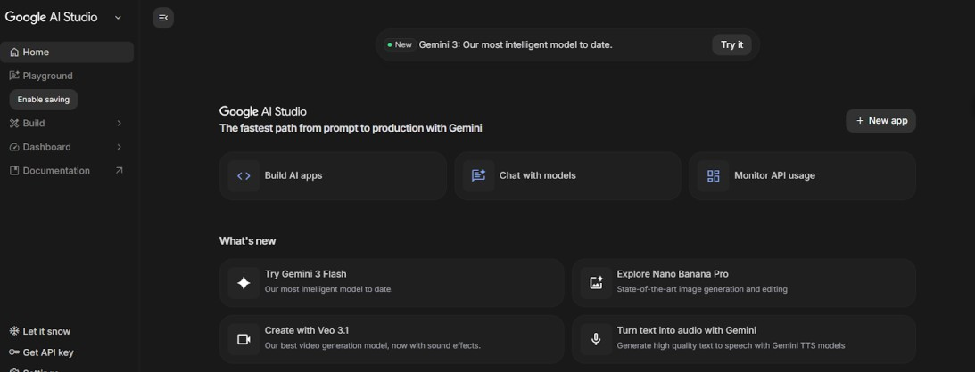
2. Sign in with Google account
3. Click 'Create API Key' and copy the generated key
4. Add key to .env file: GEMINI_API_KEY=your_key_here


5. Set AI_MODEL=gemini in .env to enable enhanced mode
6. Install google-generativeai package (included in requirements.txt)

  - MILESTONE 2: Core Services Development
This milestone focuses on building the core AI-powered services of the Social Mood Matcher system. Each service is implemented as a separate, testable module with clearly defined responsibilities. Together, these modules process user inputs, analyze moods, and generate appropriate social media captions. The modular design ensures the system is easier to manage, test, and enhance over time.

  - Activity 2.1: Image Sentiment Detector Service
Create the image_sentiment.py service that uses BLIP for image captioning and DistilBERT for sentiment analysis. This service is the first step in the content generation pipeline.
Key Features:
• Load and cache BLIP image captioning model
• Load and cache DistilBERT sentiment analysis model
• Process images to extract visual descriptions
• Analyze sentiment from image captions and visual cues
• Classify into 10 mood categories (happy, cozy, aesthetic, calm, etc.)
• Detect image categories (food, travel, nature, lifestyle)
• Return confidence scores for all detected sentiments
  - Activity 2.2: Caption Generator Service
Create the image_sentiment.py service, the first step in the Social Mood Matcher pipeline, using BLIP for image captioning and DistilBERT for sentiment analysis. It extracts detailed visual descriptions, analyzes emotional tone, and classifies images into 10 moods (happy, cozy, aesthetic, calm, etc.) while detecting categories like food, travel, nature, and lifestyle. The service also returns confidence scores for all detected sentiments, enabling nuanced content recommendations. Its modular design ensures efficient model caching and easy integration into the content generation pipeline.

Supported Styles:
Style | Characteristics | Emoji Usage
Casual | Friendly, relaxed tone | Moderate (2-3)
Aesthetic | Poetic, artistic language | Minimal (0-1)
Professional | Polished, informative | None
Playful | Fun, energetic tone | High (3-5)

  - Activity 2.3: Hashtag Engine Service
Build the hashtag_engine.py service to provide curated and trending hashtags organized by category and sentiment, helping maximize social media engagement. It includes 2024’s most popular hashtags across key categories such as Food, Travel, Nature, and Lifestyle. Each category offers highly relevant tags like #Foodie, #Wanderlust, #NatureLover, and #LifestylePhotography to boost post visibility. The service enables dynamic hashtag suggestions based on mood and content, making it easy for users to enhance their posts and reach the right audience.

  - Activity 2.4: Character Limiter Service
The Character Limiter Service ensures all generated captions and content fit within the character limits of different social media platforms. It automatically checks text length and trims or adjusts content while preserving the original message and meaning. This service supports platform-specific constraints, making content compatible and readable. By doing so, it ensures that captions and posts are ready for seamless sharing and engagement across multiple social media channels.

Platform | Character Limit | Truncation Strategy
Twitter/X | 280 | Prioritize caption, truncate hashtags
Instagram | 2,200 | Rarely needed, full content usually fits
Facebook | 63,206 | Almost never needed

  - Activity 2.5: Optional Gemini Service Integration
Create the gemini_service.py for users seeking enhanced AI capabilities and superior caption quality. This service offers advanced sentiment detection with higher accuracy, multiple caption variants (aesthetic, punchy, descriptive), and visual intelligence features such as dominant colors and detected objects. It also provides composition tips to improve photography and generates more creative, contextually relevant captions. With these enhancements, users can produce highly engaging and visually aware social media content. The modular design ensures easy integration into the Social Mood Matcher pipeline.

  - MILESTONE 3: Backend Implementation

This milestone focuses on integrating all services into a cohesive backend architecture within the Streamlit application. It ensures smooth communication between modules such as image sentiment analysis, hashtag generation, character limiting, and enhanced AI captioning. Proper session state management is implemented to maintain user data and interactions across the app. Robust error handling is included to gracefully manage failures and edge cases. Efficient caching is used to optimize performance and reduce repeated model loading. This integration lays the foundation for a responsive, reliable, and user-friendly Social Mood Matcher experience.

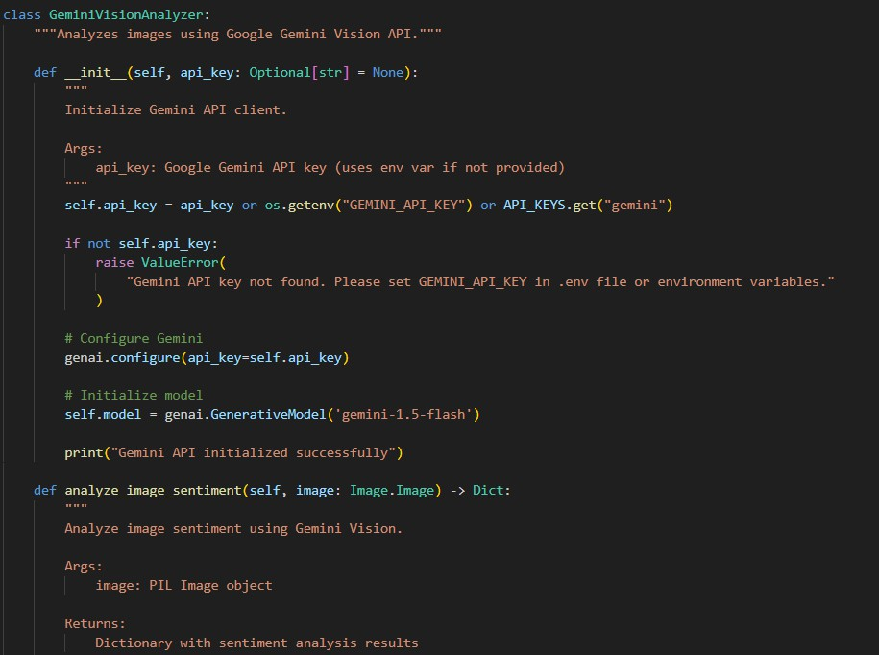

  - Activity 3.1: Session State Management
Implement proper Streamlit session state to preserve user selections, generated content, and application data across reruns. Ensure all key variables are initialized at startup to maintain consistency. This allows a seamless and interactive user experience without losing context during app updates.
• Enhanced sentiment detection with higher accuracy
• Multiple caption variants (aesthetic, punchy, descriptive)
• Visual intelligence: dominant colors, detected objects
• Composition tips for better photography
• More creative and contextually relevant captions
  - Activity 3.2: Service Initialization and Caching

Use Streamlit's @st.cache_resource decorator to load AI models once and reuse across sessions. This significantly improves performance by avoiding repeated model loading.
• ImageSentimentDetector: BLIP and DistilBERT models (~2GB)
• CaptionGenerator: Template-based generation system
• HashtagEngine: Curated hashtag database
• CharacterLimiter: Platform rules and truncation logic
• GeminiAnalyzer (Optional): Gemini API client

  - Activity 3.3: Error Handling and Validation
Implement robust error handling for file uploads, model inference, and API requests, providing clear, user-friendly messages and reliable fallback mechanisms to ensure smooth application operation.
1.Invalid file format: Show supported formats (JPG, PNG, WEBP)
1. File size too large: Display max upload size (10MB)
2. Model loading failure: Show retry option or use cached models
3. Gemini API error: Automatically fall back to local models
4. Empty generation: Retry with adjusted parameters

  - Activity 3.4: Image and Text Processing Utilities
Implement a set of utility functions in the utils/ directory to handle common image and text operations used throughout the application. These functions can include image preprocessing, resizing, format conversion, text cleaning, and tokenization. Centralizing these operations promotes code reusability and reduces duplication across modules. It also makes the application easier to maintain and update. By standardizing image and text handling, the utilities ensure consistent input processing for all services. This approach improves both development efficiency and overall application reliability.
image_utils.py: validate_image(),resize_image(),preprocess_for_model(),
create_thumbnail()
text_utils.py: clean_text(),format_hashtags(),truncate_text(),
smart_truncate_with_hashtags()

  - MILESTONE 4: UI Development
Create an intuitive and visually appealing Streamlit interface with a clean, responsive design. Ensure clear navigation so users can easily access all features of the Social Mood Matcher. Provide real-time feedback during content generation to keep users informed of progress. Incorporate visual cues and layout consistency for a smooth user experience. The interface should make interacting with AI-powered tools simple, engaging, and efficient.

  - Activity 4.1: Main Layout Design
Design a two-column layout with image upload on the left and results display on the right. Include custom CSS for enhanced visual appeal.
• Header with gradient title and subtitle
• Sidebar for settings (style, platform, hashtag count, Gemini toggle)
• Left column: Image upload with preview
• Right column: Tabbed results (Content, Visual Pro, History)
• Custom color scheme matching brand (purple gradient)
• Responsive design for mobile and desktop

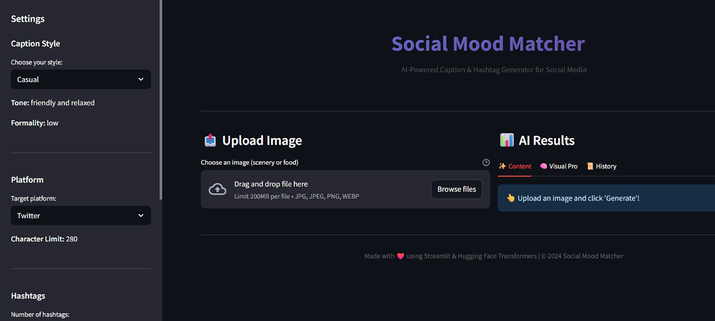
  - Activity 4.2: Sidebar Controls
Implement sidebar with user controls for customizing generation parameters.
• Caption Style: Select from Casual, Aesthetic, Professional, Playful
• Platform: Choose Twitter/X, Instagram, or Facebook
• Number of Hashtags: Slider from 3 to 15
• Use Gemini API: Toggle for enhanced vs local mode
• About Section: App description and features
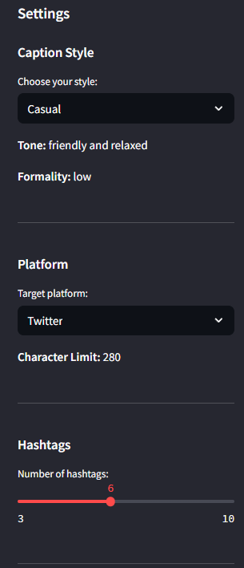

  - Activity 4.3: Results Display
Create tabbed interface for displaying different types of results:

- Content Tab:
- Sentiment badge
- Caption variants selector (Gemini)
- Generated caption
- Hashtags
- Character count
Visual Pro Tab:
- Visual intelligence analysis (Gemini only)
- Dominant colors
- Detected objects
- Composition tips

- History Tab:
- List of the previous 5 generations
- Sentiment indicators and timestamps

  - Activity 4.4: Export Functionality
Comprehensive testing ensures the application’s reliability, accuracy, and performance. This milestone covers unit tests, integration tests, and performance checks. It helps identify issues early and ensures smooth, efficient operation across all modules.

  - MILESTONE 5: Testing & Optimization
Comprehensive testing guarantees the app’s reliability, accuracy, and performance. This milestone encompasses unit tests, integration tests, and performance optimization.

  - Activity 5.1: Unit Testing
Test individual components using py testframework.Each service should have comprehensive test coverage.
• TestImageProcessor: Image validation, resizing, preprocessing
• TestTextProcessor: Text cleaning, hashtag formatting, truncation
• TestCaptionGenerator: Caption generation for all styles and sentiments
• TestHashtagEngine: Hashtag retrieval, filtering, priority-based selection
• TestCharacterLimiter: Platform limits, smart truncation, edge cases

  - Activity 5.2: Integration Testing
Test the complete pipeline from image upload to final content generation
• Upload image Sentiment detection Caption generation Hashtag retrieval
Character limiting
• Test with multiple image types: food, travel, nature, lifestyle
• Verify all caption styles produce appropriate outputs
• Validate character limits for all platforms
• Test Gemini fallback when API fails

  - Activity 5.3: Performance Optimization
Optimize application performance for faster response times and better user experience.
• Use @st.cache_resource for model loading (prevents reloading)
• Implement image resizing before model inference (faster processing)
• Add loading spinners during AI operations (better UX)
• Cache Gemini API client to avoid repeated initialization
• Optimize session state updates to minimize reruns

  - Expected Performance Metrics
Operation | First Run | Subsequent Runs
Model Loading | 30-60 seconds | Instant (cached)
Image Analysis | 3-5 seconds | 2-3 seconds
Caption Generation | 1-2 seconds | 1-2 seconds
Gemini API Call | 2-4 seconds | 2-4 seconds
Total (Local Mode) | ~35-70 sec first | ~5-8 sec
Total (Gemini Mode) | ~5-10 sec | ~4-6 sec

  - Deployment Guide
Social Mood Matcher can be deployed across multiple platforms for maximum accessibility. This section covers deployment on Streamlit Cloud as well as major cloud providers like AWS, GCP, and Azure. Guidance includes setup, configuration, and best practices for each platform. The goal is to ensure smooth, scalable, and reliable application hosting.
1. Push code to GitHub repository
2. Visit https://share.streamlit.io and sign in
3. Click 'New app' and select your repository
4. Configure main file path (app.py) and Python version (3.10)
5. Add secrets: Go to Advanced Settings Secrets
6. Deploy and wait for build completion (~5 minutes)

  - Option 2: Cloud Platforms (AWS/GCP/Azure)
Deploy on cloud platforms for production-grade scalability and reliability. Use managed container services like AWS ECS, Google Cloud Run, or Azure Container Instances.
- AWS ECS (Elastic Container Service)
- Google Cloud Run
- Azure Container Instances

  - Troubleshooting Guide
Issue: Models not loading
• Check internet connection for first-time download
• Verify MODEL_CACHE_DIR has write permissions
• Ensure sufficient disk space (~2GB)
• Try clearing cache: rm -rf models_cache/
Issue: Gemini API errors
• Verify API key is correct in .env file
• Check API quota at Google AI Studio
• Ensure google-generativeai package is installed
• Application automatically falls back to local models

Issue: Session state issues
• Clear browser cache and reload page
• Check for proper session state initialization
• Verify all session variables are defined

Issue: Character limit not working
• Verify platform selection matches expected limit
• Check smart_truncate_with_hashtags() logic
• Test with different caption/hashtag combinations

Issue: Image upload failures
• Check file format (JPG, PNG, WEBP only)
• Verify file size is under 10MB
• Ensure image is not corrupted
• Try different image or resize before upload

Conclusion
Social Mood Matcher revolutionizes social media content creation by generating intelligent, AI-driven captions and hashtags tailored to both image sentiment and user preferences. By combining BLIP for image understanding, DistilBERT for sentiment analysis, and optionally Gemini 2.5 Flash for enhanced quality, the system interprets visual content with precision. It transforms raw images into meaningful, engaging content optimized for each platform. The AI ensures that captions resonate with the intended mood and context.
The platform is built on a modular service architecture, where each component handles a specific task, from image sentiment analysis to hashtag generation and character limiting. This design ensures maintainability, testability, and easy scalability. The Streamlit interface offers a responsive, user-friendly environment, allowing content creators to interact with the AI effortlessly. Real-time feedback keeps users informed during content generation.
Every service is optimized for efficiency and reliability. Models are cached to reduce loading times, error handling safeguards against failures, and platform-specific adjustments ensure compatibility with social media constraints. The system automates repetitive tasks while maintaining the integrity of content, allowing creators to focus on creative decisions. Sentiment detection, mood classification, and character-limited outputs work together to produce high-quality posts consistently.
Whether creating a quick Instagram post or crafting the perfect Twitter caption, Social Mood Matcher acts as an intelligent content assistant. It delivers multiple caption variants, suggests trending hashtags, and provides visual insights like dominant colors or composition tips. By combining AI-driven intelligence with usability-focused design, the platform saves time, boosts engagement, and ensures that every post is authentic, creative, and optimized for maximum impact.

  - Future Enhancements
  - Support for video content analysis
  - Multi-language caption generation
  - A/B testing for caption variants
  - Social media analytics integration
  - Batch processing for multiple images
  - Custom hashtag training based on user preferences
  - Direct posting to social media platforms
  - Brand voice customization
  - Collaborative features for team accounts

